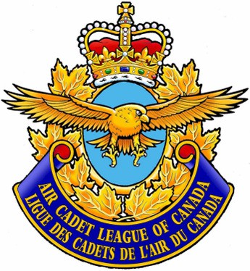

AIR CADET LEAGUE OF CANADA

2025 Nomination Slate

Executive Committee
President: Marc Lacroix CD
First Vice-President: Jacquie Pepper-Journal CD
Vice-President: Sue Madden, CPA, CGA
Vice President: Thomas Sand CD
Vice-President: Angèle Mullins

Board of Governors
Executive Committee Plus:
Dee Davis
Kevin Robinson
John Nolan
William Cahill
Terri Hinton
Arlo Speer
Vern Toews
Michele Claveau CD
Lokesh Purbia
Patrick Stoddart

Associates at Large (appointed by the Board)
Duane Schippers
James Simiana CD
Terrence Bayrock

Patron and Honoraries

Patron
Her Excellency the Right Honourable Mary Simon, CC, CMM, COM, OQ, CD
Governor General and Commander-in-Chief of Canada

Honorary Officers  Honorary President:  Honorary Treasurer: Bob Robert CD  Honorary Secretary: Leonard G. Jenks CD  Honorary Solicitor: Mervin Ozirny CD  Honorary Directors  Brigadier-General (Ret) William Buckham CD  Lieutenant-General (Ret) Fred Sutherland CMM, CD, BA, MBA, DScMil | Honorary Life Associates  Richard Logan  Robert L. Mortimer CD  Maurice J. Murphy  Russell Gallant  Jerry Elias CD

