Using the ACC-9 Summary Report

- You need to create a folder on your computer “c:\ACC9_Reports” and place all the electronic versions of the ACC-9 that you want to analyze in this folder.

- Open the new Excel file “Summary_Report.xlsm”

- Make sure that you enable macros to run:

- Click on the Get Data button:
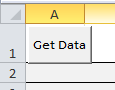

This will activate the macro and read in all of the data from the files you placed in the c:\ACC9-Reports folder.

- The top menu will show all of the line items with descriptions and a total for each line item for all squadrons.

- Once you are done with the report, the content data can be cleared by clicking on the Clear Data button:

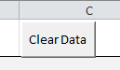

- The top menu also has 2 more buttons available for sorting either by Squadron number or by Region.

