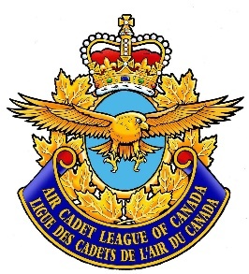

For Immediate Release

RANK FIRST NAME LAST NAME WINS EFFECTIVE SPEAKING COMPETITION

CITY, ON – Month, Day, Year: Local Air Cadet Rank First Name Last Name finished in first place of his/her local/regional/provincial effective speaking competition.

Rank last name expressed his/her excitement over this achievement. “QUOTE”
Rank first name last name prevailed over X number other contestants. He/She successfully delivered a 5-minute prepared speech on Topic and a 2-minute speech impromptu speech on Topic. He/She will now have the honour of representing his/her squadron and his/her city/region/province at the next regional/provincial/national competition held in Location on Date.
Rank last name has been a member of 000 “XX” Squadron in location for the past xxx years where he/she has been an active participant in the list activities.
The effective speaking program is an experience in individual development. The speaker’s own growth, measured against his or her own previous experience and accomplishments, is the most important feature of the competition. Air Cadets are aiming to be more valuable members of society. They are learning to organize and present ideas, opinions, and information in a logical, persuasive manner. They are building confidence in self-expression. They are taking responsibility for the most important skill of adult life – communication.
“Quote from SSC Chair, CO or PC Chair about the importance and value of the effective speaking program.” Keep it to one or two sentences.
The Royal Canadian Air Cadets, in partnership with the Air Cadet League of Canada has been training youth in Canada for over 75 years. The Cadets are the largest government funded youth program in Canada with over 50,000 cadets across Canada, Air Cadets comprising half of that total. The Royal Canadian Air Cadets accepts youth between the ages of 12-18 who have a desire to learn more about the air element of the Canadian Forces, wish to develop the attributes of leadership and good citizenship and who wish to promote physical fitness. Air Cadet uniforms are supplied free of charge. While the program is military based, there is no obligation for a cadet to join the Canadian Armed Forces when he or she finishes their cadet career. Cadets are also encouraged to learn more about opportunities within Canada’s aviation industry. The Air Cadet Program has graduated some very notable Canadians such as astronaut Col Chris Hadfield, CBC Meteorologist Johanna Wagstaffe and several members of the military performance flying team, the Snowbirds.
For more information on the Royal Canadian Air Cadets, please visit www.cadets.ca.
For more information about the Air Cadet League of Canada, please visit www.aircadetleague.com.

###

Media Contact
Name
Position
Phone
E-mail

