For the Single Account versions (acc9sv15.1.xls & acc9sv15.1_Excel2003.xls), Multi Account instructions at end of this document!

- Open the file in Excel.

- Select ACC9 (Page 3) Expenses worksheet
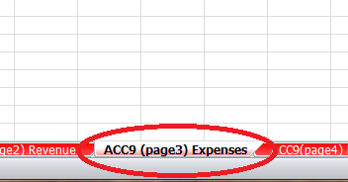
- Select the Review tab and then Unprotect Sheet

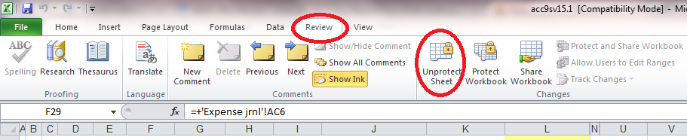

- Select the cell to the right of expense item 5850
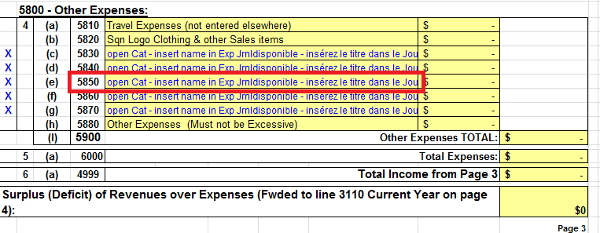
- In the formula line, change AW to AV

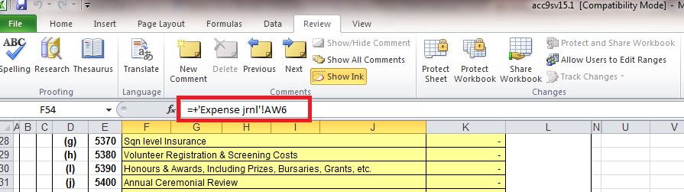

- Protect the worksheet by selecting Protect Sheet under the review tab.

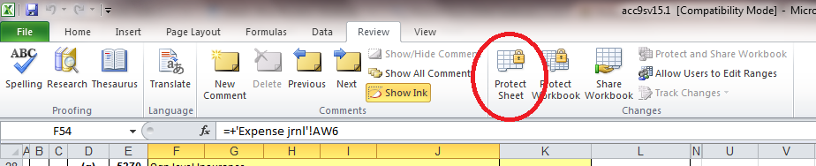

- A pop-up will appear, select Ok. Do not change any of the check marks or add a password.

- Save the file

For the Multi Account versions (acc9mv15.1.xls & acc9mv15.1_Excel2003.xls)

- Open the file in Excel.

- Select ACC9 (Page 3) Expenses worksheet
- Select the Review tab and then Unprotect Sheet

- Select the cell to the right of expense item 5850
- In the formula line, change AX to AW

- Protect the worksheet by selecting Protect Sheet under the review tab.

- A pop-up will appear, select Ok. Do not change any of the check marks or add a password.

- Save the file

